

**OFFICE OF THE PRESIDENT**

**TO : All Non-teaching Personnel** **DATE: October 27, 2020**

**THROUGH : The Deans, Directors, Principals and Office Heads**

**SUBJECT :** **No On-site Duty on Saturdays for Non-teaching Personnel**

During this pandemic, the Administration has decided that effective October 24, 2020, there shall be no more on-site duty for non-teaching personnel on Saturdays. The required number of days for on-site schedule shall be evenly distributed on Monday to Friday as Saturdays shall be work from home (WFH).

The office/department heads are requested to immediately submit their personnel's updated schedule to the Human Resource Management Office (HRMO). Should there be a need to report to the office/department on a Saturday in case of exigencies, an approval shall be sought from the proper authorities following the existing policies and procedures in this regard.

For your guidance and compliance. Thank you!

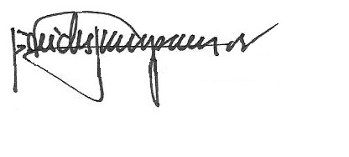

REV. FR. CRISTOPHER C. MASPARA, OAR

President

/bvs